Page 1 — Launch an EC2 Instance
Topic: AWS VPC and EC2 instance setup
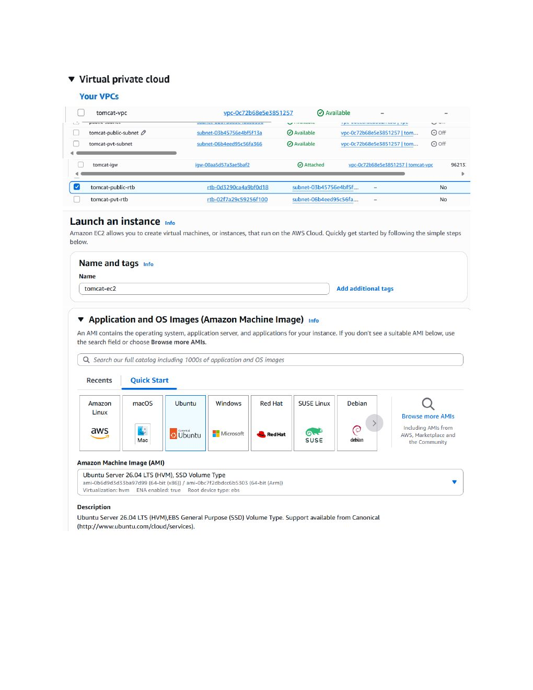
Actual action: The AWS EC2 Launch an instance page is opened, the existing VPC/subnet environment is visible, and the EC2 instance setup is started with the instance name and AMI section configured.

Page 2 — Configure the EC2 Instance
Topic: AMI, instance type, key pair and network settings
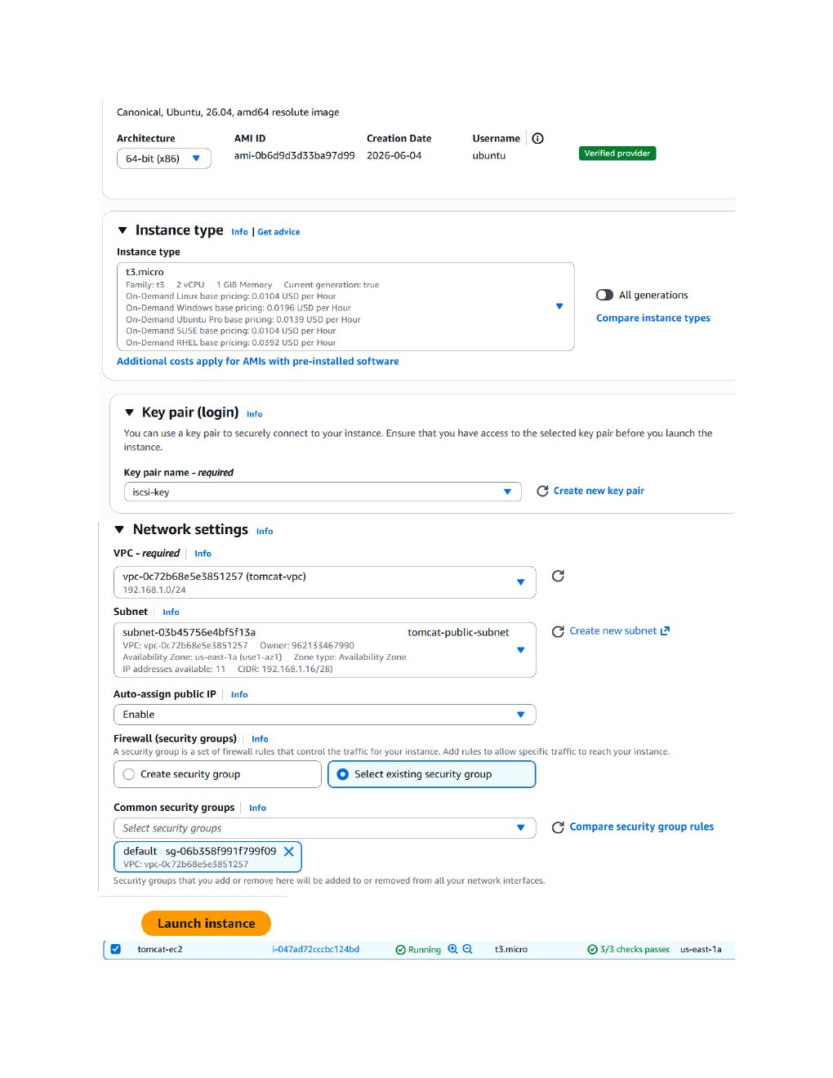
Actual action: Ubuntu 26.04 is selected as the AMI, t3.micro is selected as the instance type, the iscsi-key key pair is selected, and the VPC/network settings are configured.

Page 3 — Connect to Ubuntu EC2
Topic: Security group and SSH connection
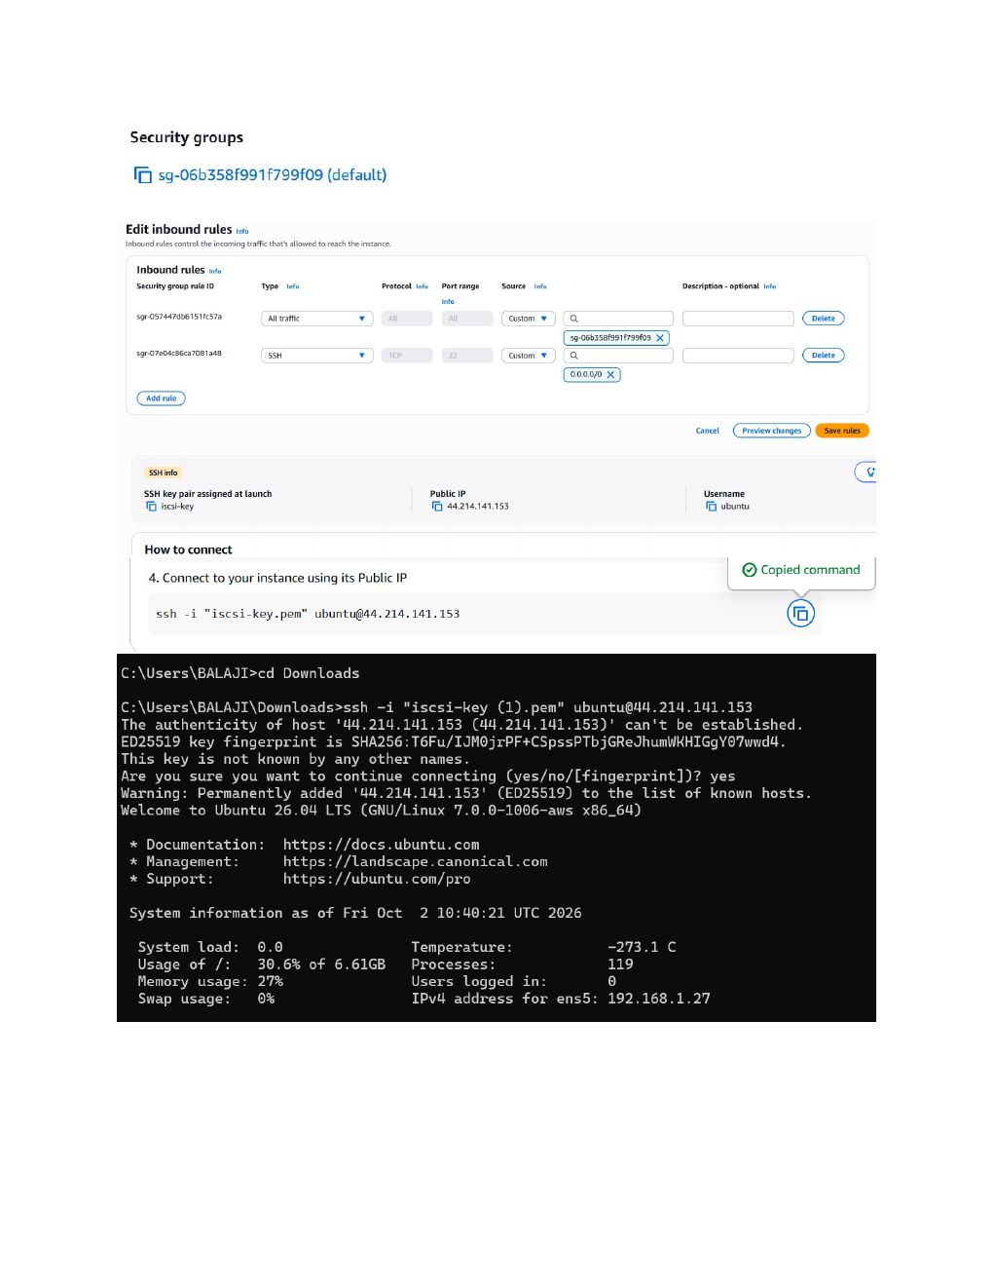
Actual action: The security-group/SSH access is reviewed, the provided SSH command is copied, and the Windows terminal connects to the Ubuntu EC2 instance using the iscsi-key PEM key.

Page 4 — Install ZIP Utility
Topic: Installing the zip package on Ubuntu
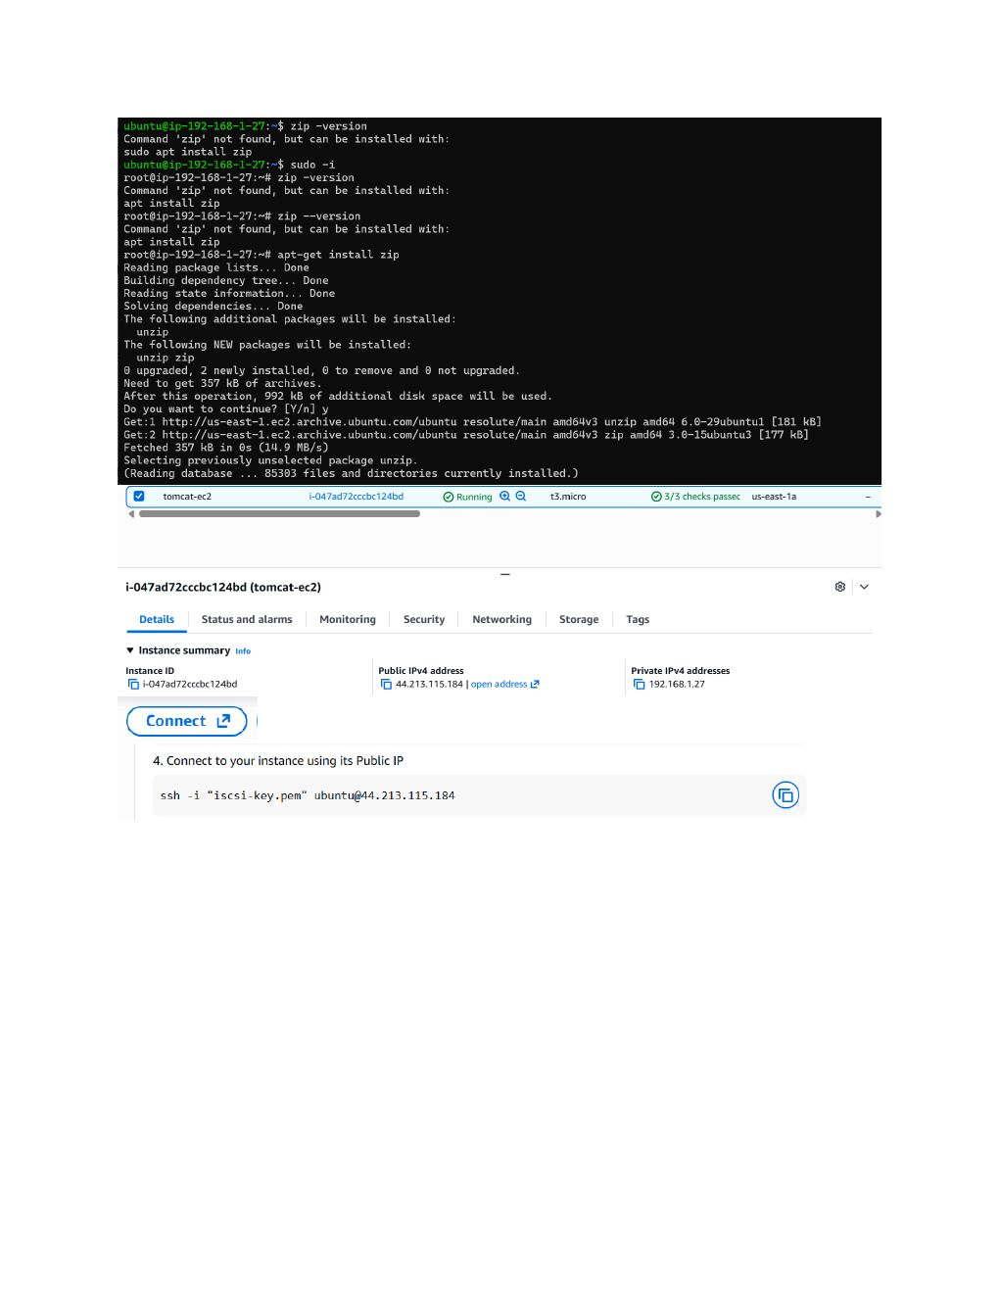
Actual action: The terminal shows that the zip command is missing; apt is used to install the zip package and its required package information is processed.

Page 5 — Package Installation Output
Topic: Ubuntu package installation and terminal verification
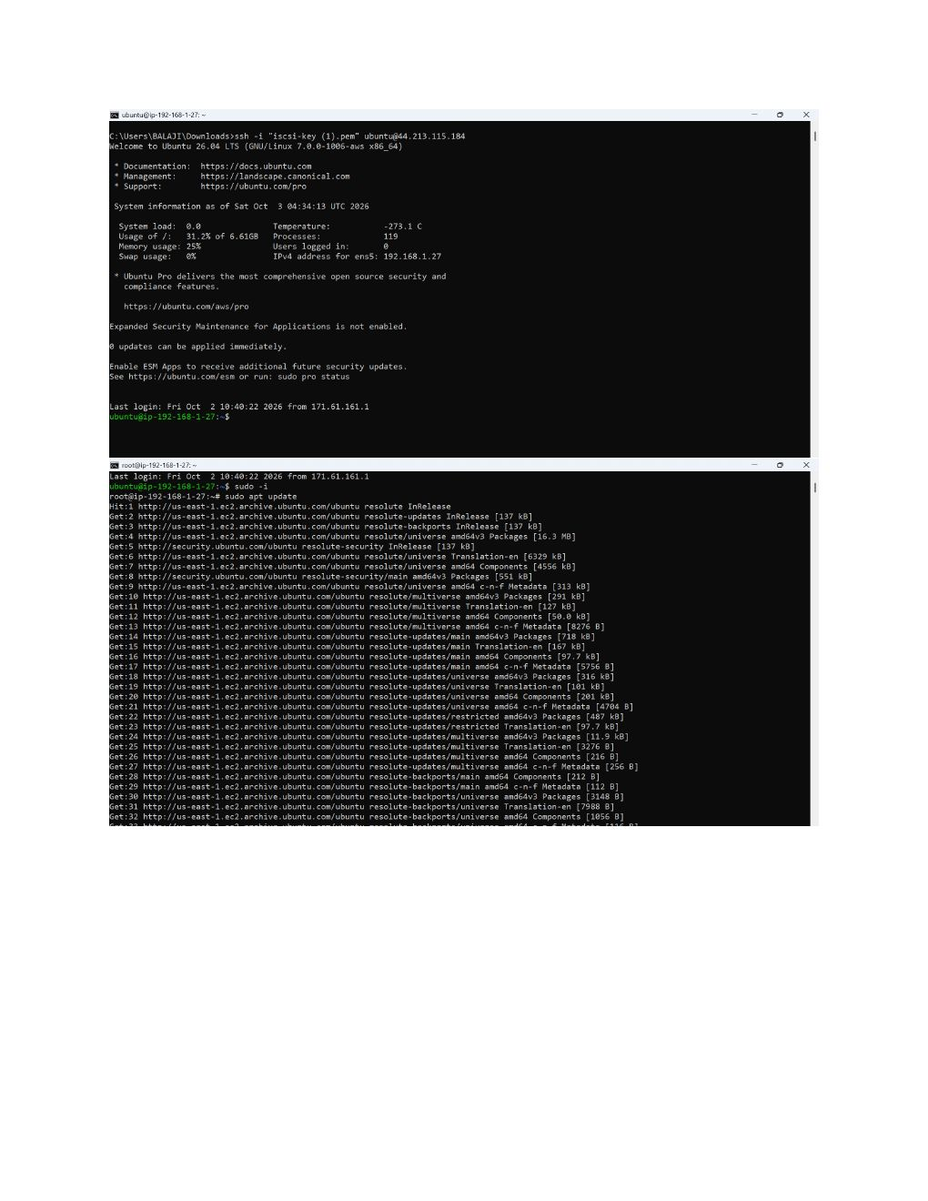
Actual action: The terminal displays the package installation/output produced while preparing the Ubuntu instance for the required software.

Page 6 — Update Ubuntu Packages
Topic: apt package update/upgrade
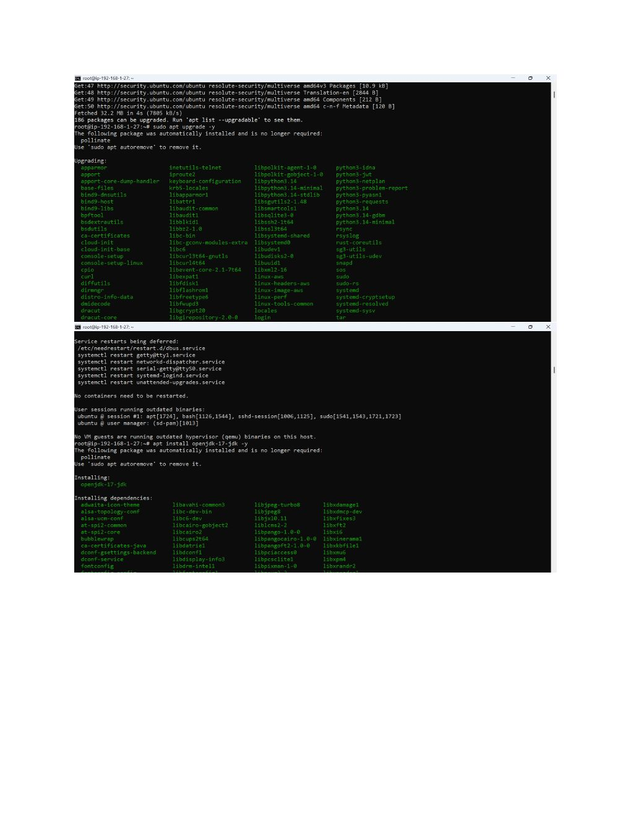
Actual action: The Ubuntu package lists and installed packages are updated/upgraded using apt, with the terminal showing the resulting package status.

Page 7 — Install Apache Tomcat
Topic: Tomcat package installation on Ubuntu
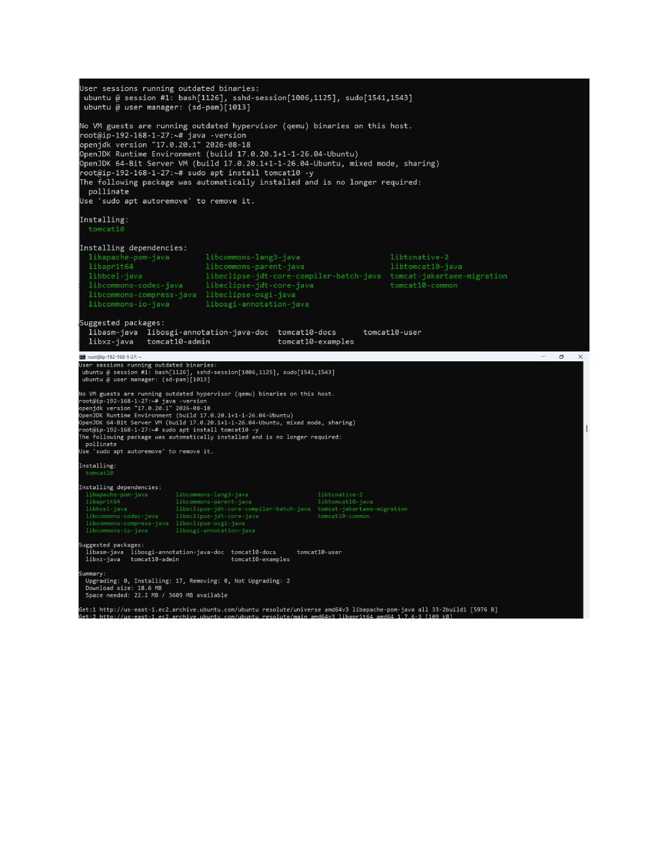
Actual action: The terminal installs the Tomcat-related packages and dependencies, including the Java/Tomcat components required to run the server.

Page 8 — Allow Tomcat Port
Topic: EC2 security group inbound access
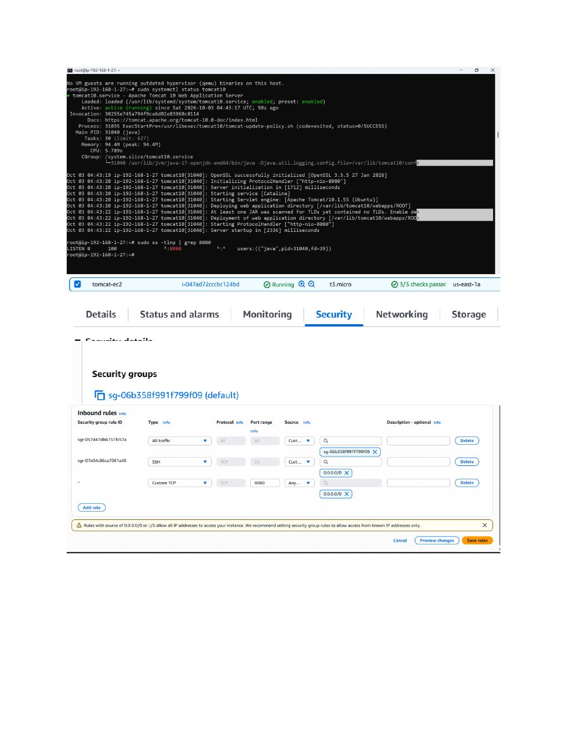
Actual action: The EC2 security group inbound rules are displayed/updated so the Tomcat service can be reached through the required port.

Page 9 — Verify Tomcat and Remove Package Installation
Topic: Tomcat web page and service management
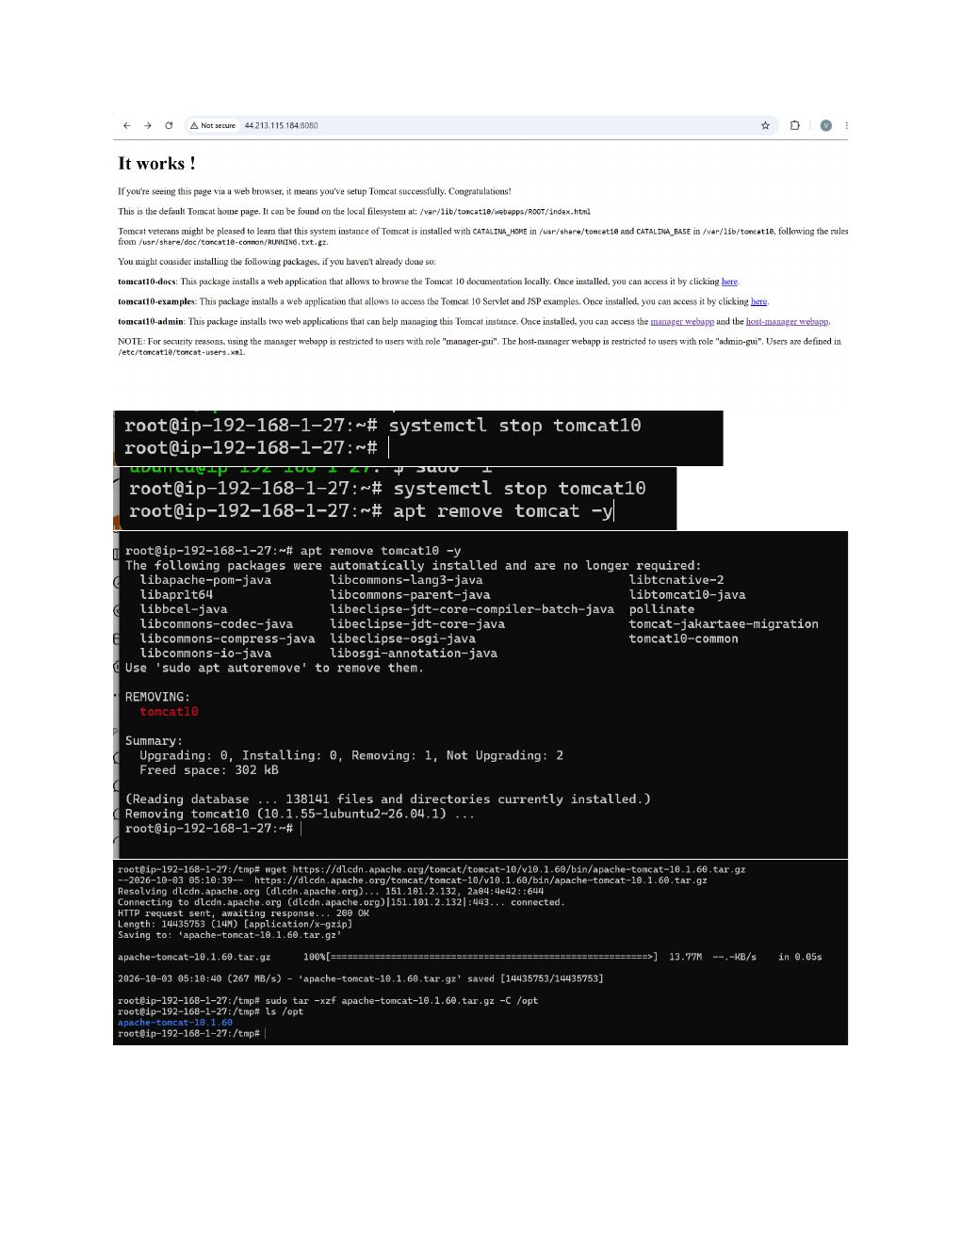
Actual action: The Tomcat default web page is opened successfully; the terminal then stops tomcat10 and begins removing the apt-installed Tomcat package.

Page 10 — Run Apache Tomcat 10.1.60
Topic: Custom Tomcat startup and browser verification
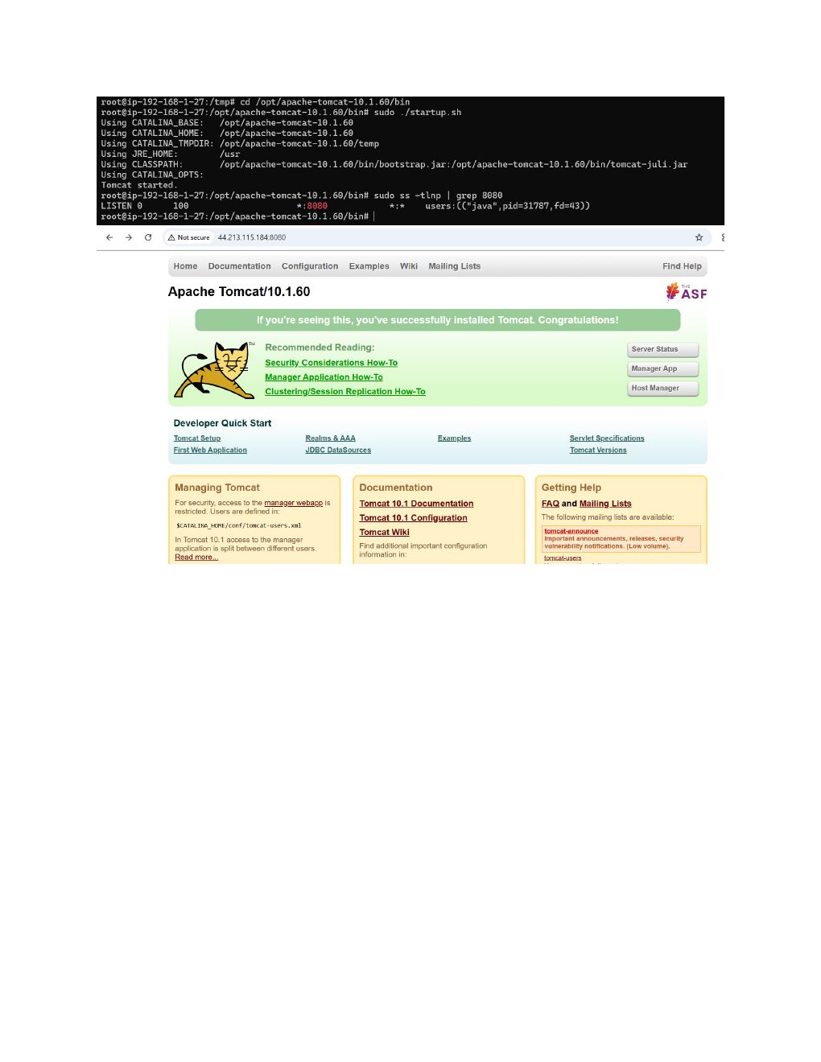
Actual action: Apache Tomcat 10.1.60 is started from its installation directory, port 9080 is checked with ss, and the Tomcat 10.1.60 page is opened in the browser successfully.

